**Home Screen**

Sales Home Page

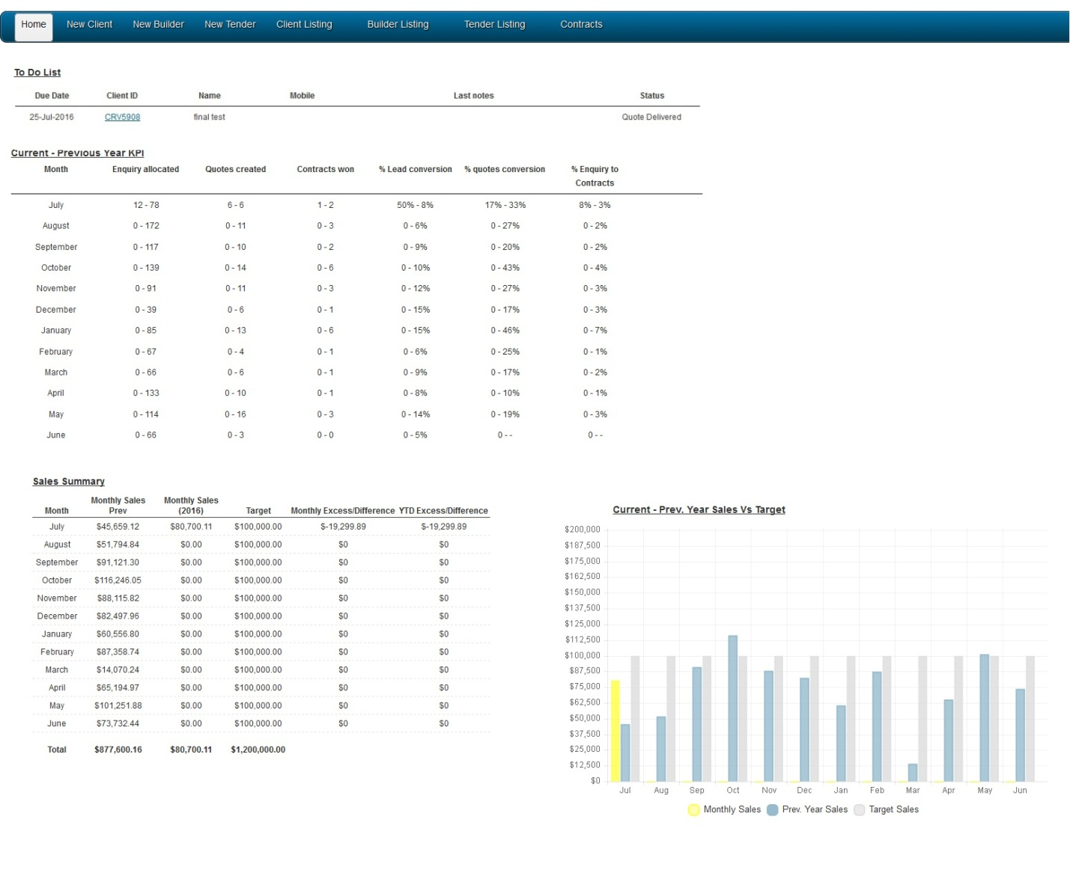

Admin Home Page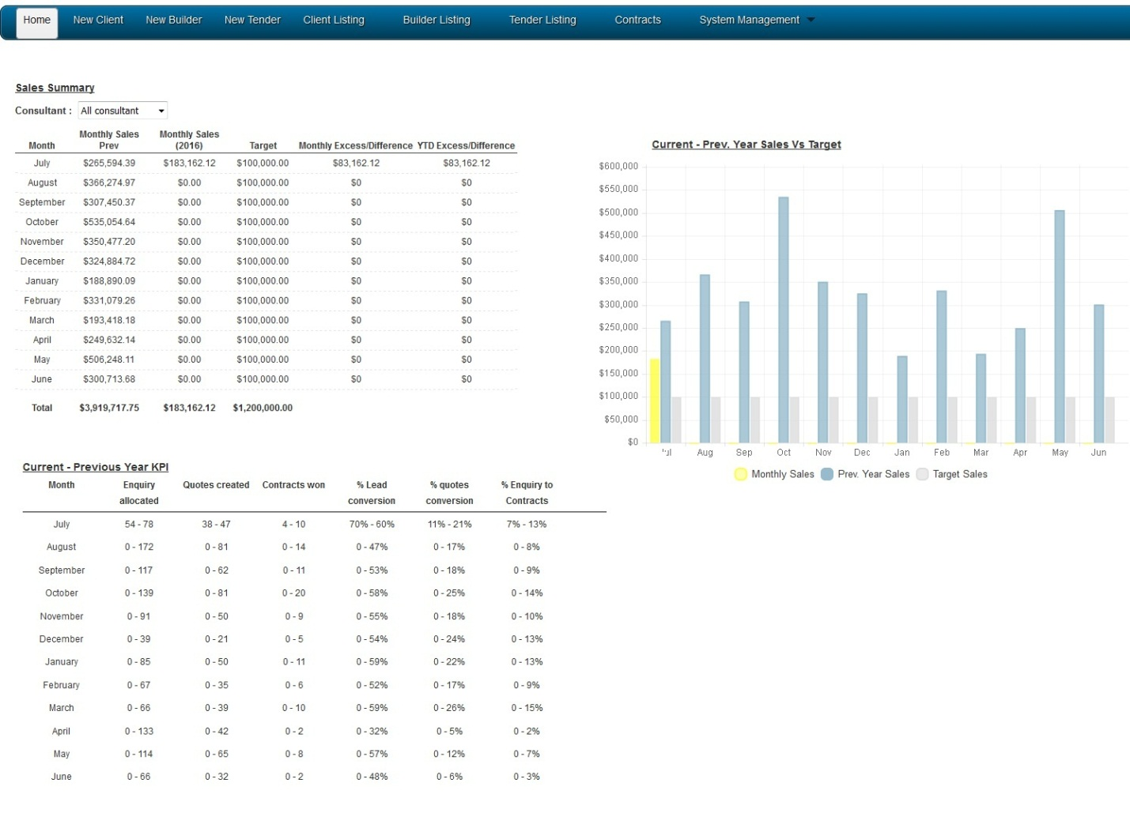

**List of files that are used**

project_folder/includes/vic/enquiry/sales_report_vic.php

**List of tables used.**

ver_chronoforms_data_quote_vic

ver_chronoforms_data_followup_vic

ver_chronoforms_data_contract_list_vic

ver_rep_sales_target

**Any plugins we used**

ChartJS

Number of Lead – date lead created = month = number

Number of Quotes – book it into the month the lead generated.  1 lead = 1 quote irrelevant of the number of actual quote created for the lead.

Make sure the sign in representative user has a target sales of the year as a reference of the home page sales summary report.

Add a sales target (System Man. -> Rep List -> select representative-> input sales target)